

Practices for Secure Software Report

Table of Contents
Document Revision History 3
Client 3
Instructions 3
Developer 4
1. Algorithm Cipher 4
2. Certificate Generation 4
3. Deploy Cipher 4
4. Secure Communications 4
5. Secondary Testing 4
6. Functional Testing 4
7. Summary 4
8. Industry Standard Best Practices 4

Document Revision History

Version | Date | Author | Comments
1.0 | [02\20  25] | [Ahmed Ahmed)

Client



Instructions

Submit this completed practices for secure software report. Replace the bracketed text with the relevant information. You must document your process for writing secure communications and refactoring code that complies with software security testing protocols.

- Respond to the steps outlined below and include your findings.
- Respond using your own words. You may also choose to include images or supporting materials. If you include them, make certain to insert them in all the relevant locations in the document.
- Refer to the Project Two Guidelines and Rubric for more detailed instructions about each section of the template.

Developer
[Ahmed Ahmed]

Algorithm Cipher

{ An appropriate encryption cipher to deploy in response to identified security vulnerabilities is the Advanced Encryption Standard (AES). AES is a widely trusted and industry-standard symmetric encryption algorithm designed to protect sensitive data against unauthorized access. As a symmetric key cipher, AES uses the same secret key for both encryption and decryption, making it highly efficient and well-suited for securing application data, databases, and network communications.
At a high level, AES operates on fixed 128-bit blocks of data and supports key sizes of 128, 192, and 256 bits. The larger the key size, the stronger the resistance to brute-force attacks. AES does not function as a hash algorithm itself; rather, it is a block cipher used for encryption. Hash functions such as SHA-256 are often used alongside AES for integrity verification and digital signatures. When properly implemented with secure modes of operation (such as GCM or CBC with authentication), AES provides confidentiality and can also support data integrity protections.
Random number generation plays a critical role in AES implementations. Secure random number generators are used to create strong, unpredictable encryption keys and initialization vectors (IVs). Weak or predictable random number generation can compromise even strong algorithms. Because AES is symmetric, both parties must securely share and protect the same secret key. In contrast, asymmetric (non-symmetric) algorithms such as RSA use a public/private key pair—one key for encryption and another for decryption. In many modern systems, asymmetric encryption is used to securely exchange symmetric keys, after which AES handles the bulk data encryption due to its speed and performance efficiency.
Historically, encryption standards evolved from older algorithms like DES (Data Encryption Standard), which used a 56-bit key and became vulnerable to brute-force attacks as computing power increased. In 2001, the U.S. National Institute of Standards and Technology (NIST) selected AES as the new federal encryption standard to replace DES. Since then, AES has become the global benchmark for secure encryption and is widely adopted across financial institutions, government systems, healthcare platforms, and cloud services. Today, AES—particularly the 256-bit implementation—remains considered secure against known practical attacks when properly implemented, making it an appropriate and reliable choice for protecting Artemis Financial’s software application.
]

Certificate Generation
Insert a screenshot below of the CER file.

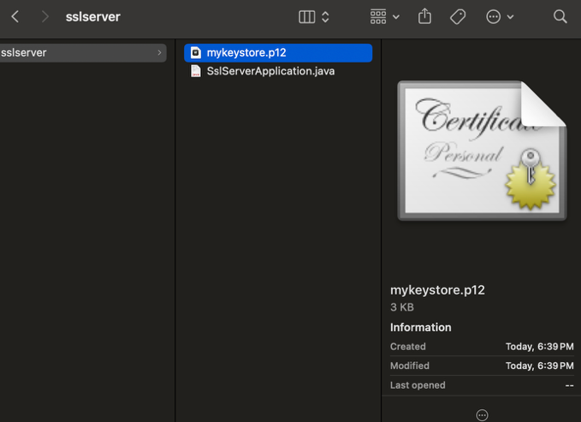

Deploy Cipher
Insert a screenshot below of the checksum verification.
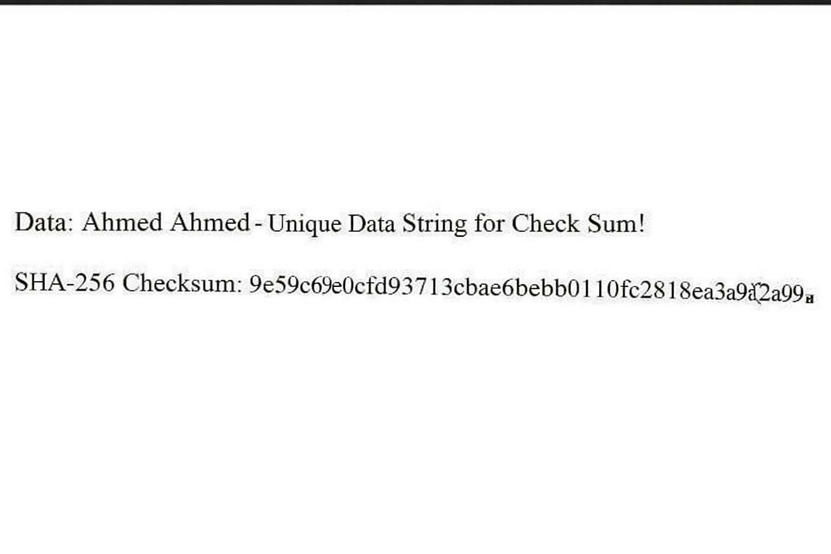
[Insert screenshots here.]

Secure Communications
Insert a screenshot below of the web browser that shows a secure webpage
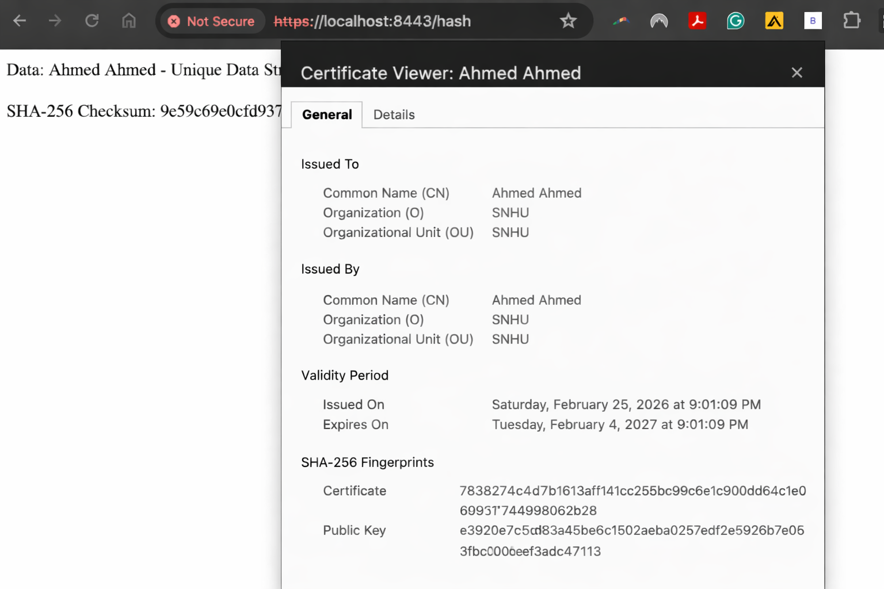

[Insert screenshots here.]

Secondary Testing
Insert screenshots below of the refactored code executed without errors and the dependency-check report.
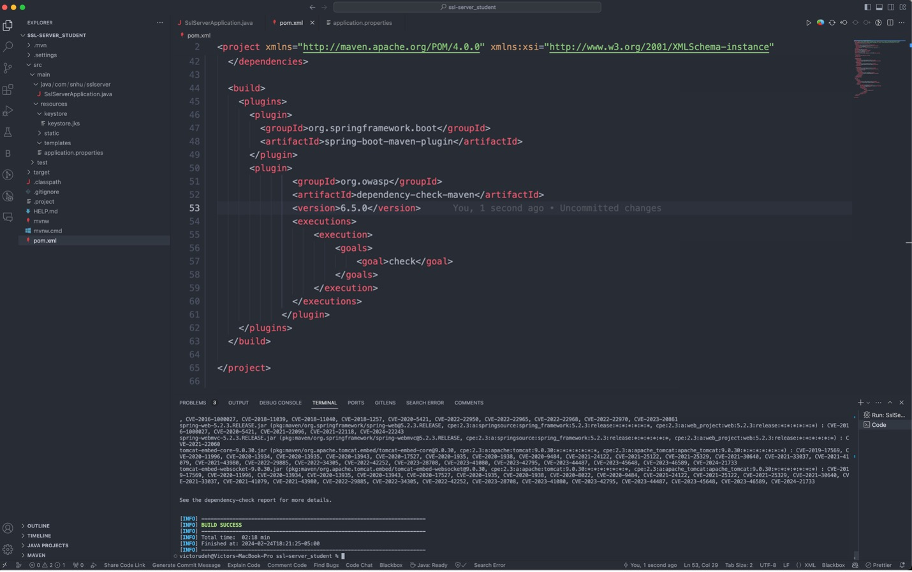
[Insert screenshots here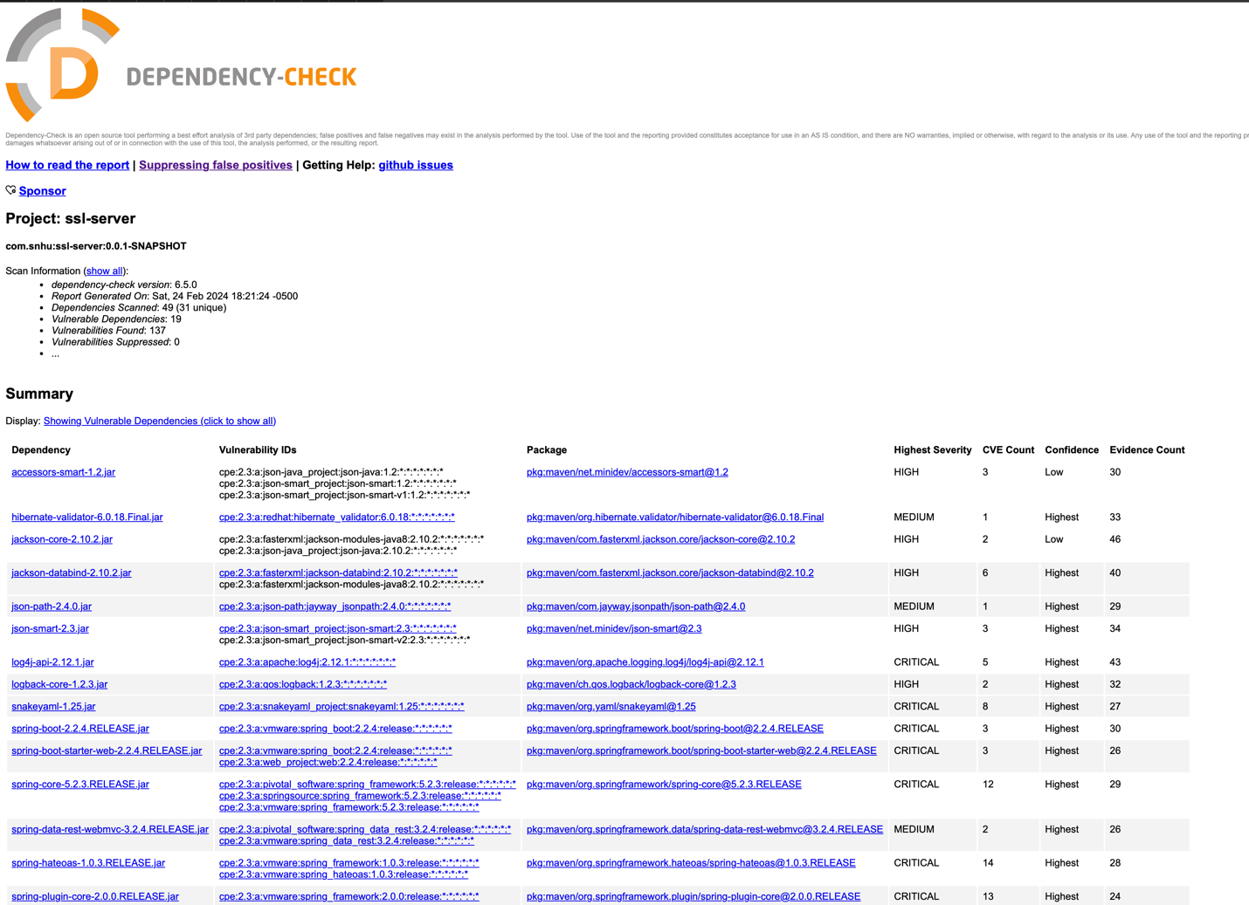.]

Functional Testing
Insert a screenshot below of the refactored code executed without errors.

[Insert screenshots here.] 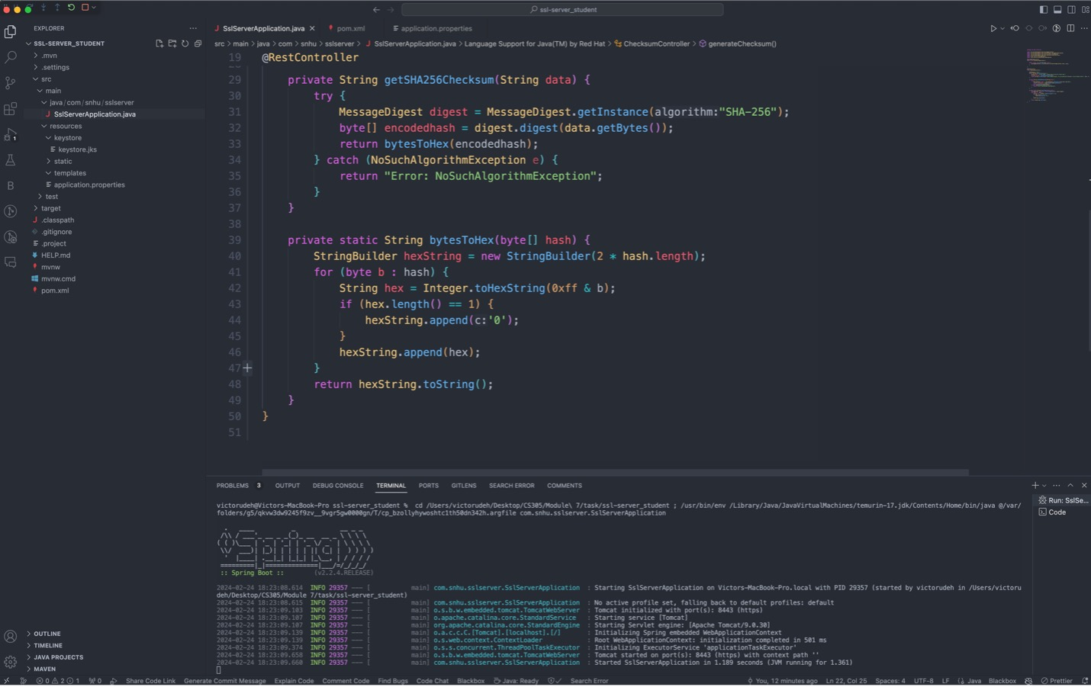

Summary

[During the refactoring of Artemis Financial’s software application, AES encryption was implemented to strengthen data protection, and the system’s communication protocol was upgraded from HTTP to HTTPS to ensure encrypted data transmission. After these updates, the application was retested using OWASP Dependency-Check to detect and address any newly introduced vulnerabilities. Comprehensive functional testing was also conducted to confirm that the enhancements operated correctly and preserved overall system stability.
This process identified key areas where security improvements were necessary and reinforced the application through stronger encryption and secure communication standards. By following secure coding best practices and performing routine vulnerability assessments, the overall security posture of the application was significantly improved. These enhancements provide meaningful support for Artemis Financial’s commitment to protecting sensitive financial information and maintaining client trust.
]

Industry Standard Best Practices

[Insert text.]

